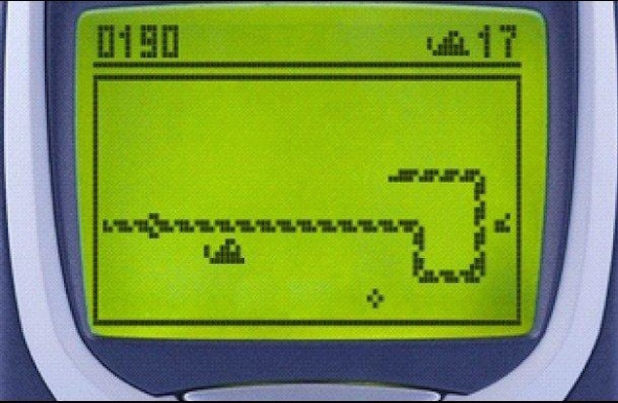

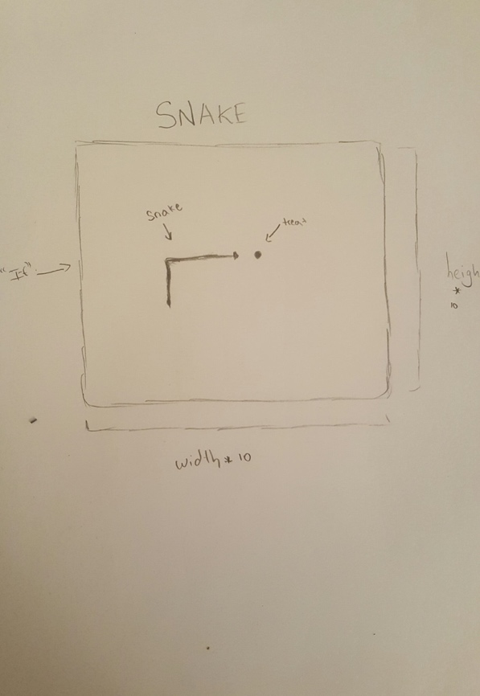My idea for the midterm project is to create the successful game SNAKE. It was created years ago, so I believe it shouldn’t be that hard. I will use push and pop functions to allow my snake to move right, left, top, or bot whenever I press the key I want. I will use ‘if’ statements to restrict my snake to touch the box lines.